Drop Missing Percentage Returns
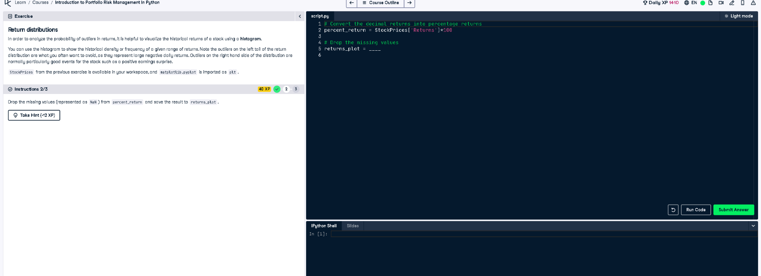

Python Code
# Convert the decimal returns into percentage returns
percent_return = StockPrices['Returns'] * 100
# Drop the missing values
returns_plot = percent_return.dropna()

Explanation
This code removes missing values (NaN) from the percent_return data using .dropna() and stores the cleaned data in returns_plot. This is important for plotting or further analysis because NaN values can cause errors or distort visualizations like histograms, which require complete numerical data.

